**CREATE IBM CLOUD ACCOUNT**

|  |  |
| --- | --- |
| Team ID | PNT2022TMID33587 |
| Project Name | Personal expense Tracker Application |

Team Leader:

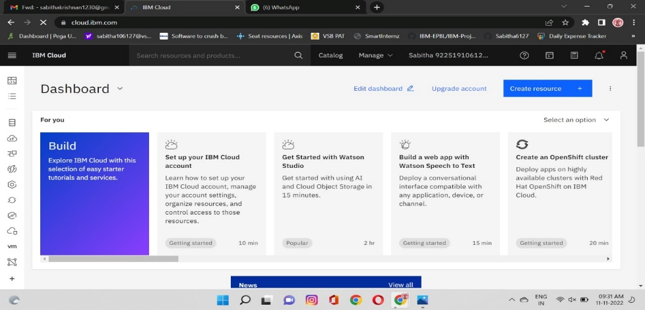

Team Member 1:

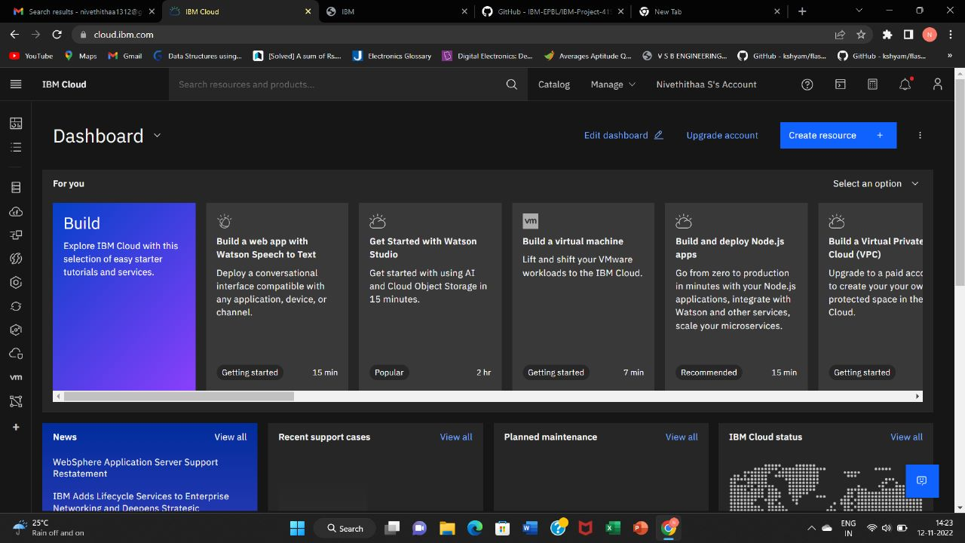

Team Member 2:

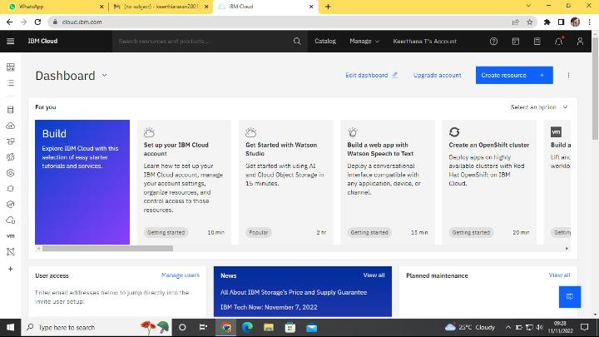

Team Member 3:

